King Street Primary & Pre - School
High Grange Road
Spennymoor
County Durham
DL166RA Telephone: (01388) 8160781
Email: kingstreet@durhamlearning.net

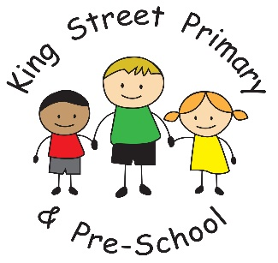

22nd October 2021

Dear Parents/Carers,

Our final day of term has arrived and we have some very tired children (and staff!). After a very busy week the children are definitely ready for a well-deserved break. The Harvest Service was lovely and felt very special to have all of our children back together to share in the event which was themed around being thankful. We do have a lot to be thankful for and the children sang beautifully and spoke eloquently. Following the church service, we had our Halloween disco which was a huge success. The children looked scarily fantastic in their outfits. Mr Swift and Miss Starkie will now be putting their efforts into the next event, which I am sure we will hear about shortly. It was a great way for children to socialise together for the first time in what feels like a very long time. Yesterday, we had our ‘show racism the red card day’ and we had huge numbers of children and staff wearing red to raise awareness- some children managed to get into red from head to toe! It was great to see the effort they all made. Finally, today we have had our school photo day and also our Spooktacular Halloween meal. Children really have had a lovely week. Look out for the photograph proofs coming out after the holidays - it will contain all of the information for ordering photos.

Donations
Thank you to all of the donations of clothing to the air ambulance. We have already received a thank you message from them and they have assured us that the collection will really help towards their fundraising efforts. Thank you also to those who donated food to the food bank. This has already been passed over and received with thanks. It will really help families in need over the next few weeks.

Freecycle uniform event
Just a reminder about our uniform event - the uniforms available are all new or nearly new and very high quality. If you would like to join our efforts to recycle and save the planet, please pop along to one of the following sessions:

Uniform size | Date and time | Venue
Age 4-7 years | Wednesday 3rd November 9am-10am | Detached ‘Hub’ building as you come into school
Age 7-9 years | Wednesday 10th November 9am-10am
Age 10+ | Wednesday 17th November 9am-10am

Fun and Food – October Half Term 2021
Whether it’s finding fun things for the kids to do, paying for extra childcare, or even just all that extra food they seem to eat, the school holidays can be a struggle for many families. Covid-19 has meant that many people’s incomes have been reduced and children and young people are keen to get out and spend time with their friends.
This October half term the Fun and Food programme is providing fun activities with healthy food for children and young people. Activities are provided by a range of partners including schools, voluntary and community sector groups and sport and leisure services.
For information on Fun and Food activities during the October half term holidays check out www.durham.gov.uk/FunAndFood They will be adding activities to the list so please keep checking back to find out more about the fabulous opportunities in our community.

I hope you all have a wonderful half term break and that the weather is kind. We will see you all on Monday 1st November for another half term of fun.
Yours Sincerely
Joanne Bromley
Headteacher

