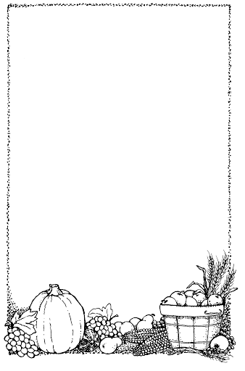
Falling Apples

Here is the tree with its leaves so green.

Here are the apples that hang between.

When the wind blows, the apples will fall.

And this is the basket to catch them all.
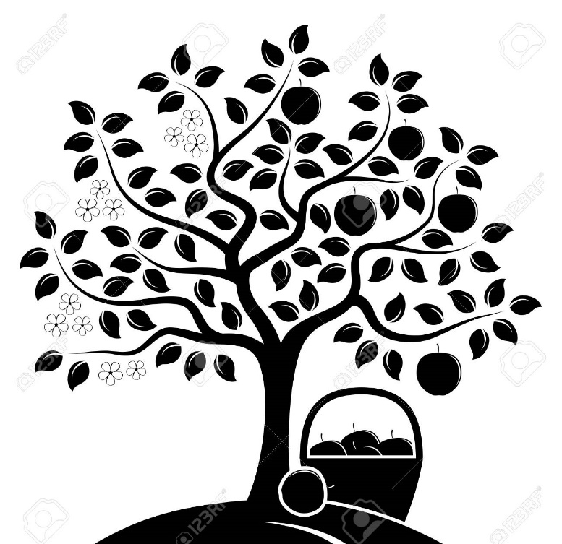

The Poetry Basket www.helicopterstories.co.uk

