King Street Primary & Pre - School
High Grange Road
Spennymoor
County Durham
DL166RA Telephone: (01388) 816078
Email: kingstreet@durhamlearning.net
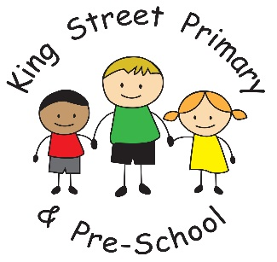

8th April 2022

Dear parents/carers,

It has been a lovely way to finish to spring term in a week where we were able to invite parents in for Stay and Play, parents’ evenings and to celebrate with a church service. This was the first time in 2 years that we have been able to welcome families into school and into church and it has been a delight to be a part of again. We are now already planning our Queen’s Jubilee Day in June.
It has also been wonderful to welcome Dennis, our new school crossing patrol, this week and I know that our children and families have already introduced themselves and made him feel very welcome.

Parking
There have been a number of concerns from residents again this week about families parking on the yellow zig zag lines and on pathways blocking the route to school. We want our children and families to be able to enter school feeling safe and stress free but, at present, the parking situation is causing many families huge concerns. I am hoping now that we have a crossing patrol that families will park a little further away and walk the short distance into the school building and help keep everyone safe.

Easter holiday clubs
Whether it’s finding fun things for children to do, paying for extra childcare, or even just all that extra food they seem to eat, the school holidays can be a struggle for many families
This Easter the Fun and Food programme is providing fun activities with healthy food for children and young people. Activities are provided by range of partners including schools, voluntary and community sector groups and sport and leisure services. For information on Fun and Food activities during the Easter holidays check out www.durham.gov.uk/FunAndFood
Also, join the Facebook group https://www.facebook.com/groups/funandfoodcountydurham
They will be adding activities to the list throughout the holidays so please keep checking back to find out more about the fabulous opportunities in our community.

Smart watches
Just a reminder that whilst we encourage children to wear watches in school to help with recognition of time, ‘smart watches’ are not allowed to be worn in school. These types of watches have camera and video capability and some can access the internet. Children wearing smart watches would cause potential safeguarding concerns due to their ability to capture photo or film others without consent. When using the internet in school, we have strict filters set up to ensure content is appropriate for children, smart watches do not have this filter and therefore are not appropriate to have in school.

Weardale residential visit
A reminder that for children in Year 4 and 5 who are participating in the Weardale residential visit, there is an information event for parents at 4pm on Wednesday 27th April. This will be held in school. Staff from the adventure centre will be explaining the activities undertaken and giving information regarding the kit list needed. If you are unable to attend, please contact us by email and we will arrange for this information to be sent to you. It is also important that you maintain your payments on Parent Pay. It is a requirement that this visit is paid for prior to departure. If you are experiencing financial difficulty please speak to us and we can look at options available to you.

Social media
It has been brought to our attention that, nationally, some scary videos are “trending” and have traumatised some children. The risks of children accidentally seeing these videos can be reduced by ensuring devices have appropriate parental controls set up. The https://www.internetmatters.org/ website provides excellent advice on how to do this. (QR Code alongside)
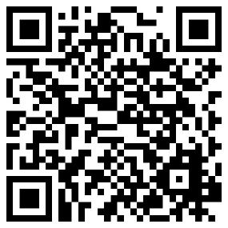
Secondly, and probably more importantly, it is important that your child can talk to a trusted adult if something scary has happened so that they are reassured. The video from CEOP (QR code alongside ) https://www.thinkuknow.co.uk/parents/jessie-and-friends-videos/ works well with younger children and maybe useful to reinforce key messages. If you have concerns then please talk to class teachers or myself for advice.

Covid isolation rules
I thought this update on isolation rules may be useful to families. The Government have now changed their guidance for children’s isolation period to 3 full days. There are now no requirements to have a negative test at the end of the period. After the holidays, these are the rules we will be adopting. The only time children would not return after 3 full days is if they still have a high temperature or remain too unwell to attend. Hopefully, we will not see high rates of infection after the holiday period but for those who are affected, the period of school being missed is much reduced.

Vaccinations
We have received information from the NHS today regarding vaccinations for 5-12 year olds. The information is as follows:
On 16 February, the Government accepted advice from the JCVI to make a non-urgent offer of Covid-19 vaccines to all children aged five to 11, to increase protection against potential future waves of COVID-19.
The National Booking Service has opened and bookings for children aged 5 to 11 can now be made.
This will not be an in-school offer, except where SAIS providers are used to provide vaccinations in special educational needs (SEN) schools.
The number of clinics will increase towards Easter to support vaccination during school holidays when parents have more time.
The NHS is already vaccinating children aged 5 to 11 who are most at risk of Covid-19 or who are a household contact of someone who is immunosuppressed.
The National Booking Service (NBS) shows available appointments and there is also a site finder to locate vaccine walk-in centres which is updated regularly. This finder shows which doses are offered at each location and to which age groups.
A flyer has also been sent out vis eschools with additional information.

We hope you all have a wonderful Easter break, fingers crossed the sun shines and families can enjoy some quality time together. We reopen for the summer term on Monday 25th April.
As always, if you have anything you would like to speak to us about, please contact the school office or speak to myself or staff on the school yard.

Yours Sincerely
J Bromley
Head Teacher

