King Street Primary & Pre - School
High Grange Road
Spennymoor
County Durham
DL166RA Telephone: (01388) 816078
Email: kingstreet@durhamlearning.net
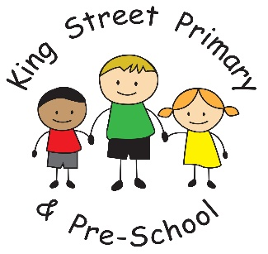

13th May 2022

Dear Parents/carers,

I would like to start this week with a huge congratulations to our Year 6 children who have shown significant resilience and determination this week when faced with their SATs papers. Each morning, they filled themselves with a fabulous breakfast of pancakes, croissants, fruit, yoghurts and crumpets and then faced the day with a smile on their face. We are incredibly proud of al of the children and today, they had a well-deserved picnic in the park. There will be many more treats and delights to follow over the remaining weeks to ensure that their final year of primary school is memorable.

Royal High Tea
By now, all families will have received their invite to our Jubilee celebrations. Not only do we have a lovely afternoon tea planned but also various activities for families to take part in. It promises to be a lovely afternoon – we just hope the weather is lovely too. Please note, there is no payment required for this event. We have offered it to families free of charge as part of national celebrations.

Movie night
Today, your child will be bringing home an information sheet for our movie night on Thursday 26th May.
Please read this carefully so that you are aware of the film options for your child. A booking link will then be sent next week for you to pick the movie. This event is not restricted numbers so all children from Reception to Year 6 will be allocated a place if they want one. Please do remember to pre-book their place.

Lateness
Just a polite reminder to families that children need to be at school by 8:55a.m. We are now seeing large numbers of children regularly attending after 9a.m. This is disruptive to their education as lessons have often started by the time they arrive and many children then feel embarrassed walking into class or a full school assembly. We are also required by the Local Authority to monitor attendance and lateness and where these become persistent issues we do request meeting with families to discuss the issues. Please make every effort for your child to arrive on time.

Diary dates
Thursday 26th May – Movie night
Friday 27th May – Royal High Tea
Wednesday 22nd June (PM) – Y1/2 sports day
Thursday 23rd June (PM) – KS2 Sports Day
Monday 11th July Y4/Y5 – Weardale residential
Thursday 14th July – School summer fair

As always, if you have any questions or concerns or would like to volunteer in school, please speak to class teachers or contact the school office.

Yours Sincerely,

J Bromley
Head Teacher

