King Street Primary & Pre - School
High Grange Road
Spennymoor
County Durham
DL166RA Telephone: (01388) 816078
Email: kingstreet@durhamlearning.net

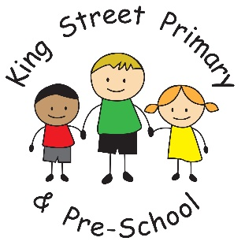

20th January 2023

Dear Parents /Carers

As the nights get lighter it feels like we are heading into Spring. The children have enjoyed breaktimes outside and our Year 2 children have thoroughly enjoyed outdoor education sessions at the beach and Herrington Park. Our EYFS children have had a great week celebrating Chinese New Year and experimenting with new tastes and learning about Chinese customs.

Our Hub community building is becoming very popular and it is lovely to see items being upcycled and put to good use. This is such an easy way for us to do our bit to help the environment and we encourage more families to come along and use the facility. There are huge amounts of clothing, uniforms, household items and a food pantry. This is all free to use and everyone is eligible. The Hub is open every Tuesday from 9am-11am and we would love to see you there.

Strike Action
You may be aware from media coverage the NEU (National Education Union) have declared strike action which will take place starting on Wednesday 1st February. Our school will be open as normal on this date.

School valentines’ disco
We are holding our school disco on Thursday 16th February. Reception, Y1 and Y2 children are invited to stay from 3:15pm-4:15pm and Year 3,4,5 and 6 children attend from 4.30pm-5.30pm. Children are to be collected from their normal exit after the event. We are going to try a totally cashless event this time and therefore the ticket cost will now include unlimited drinks, a hot dog and a bag of sweets. There will be no need to bring cash to spend on the day.
Please look out for the ticket request form coming out on Eschools tonight, ticket requests need to be submitted by Thursday 2nd February. Payment for tickets will be on ParentPay from Friday 3rd February and must be paid by Friday 10th February. Tickets will be sent home with your child by Tuesday 14th February. Please note that payment must be made for children to attend. The event is held to raise funds for the children and is used to fund playground developments and reduce the cost of school visits for families.

Flu Vaccination
We have been asked to distribute information on catch up flu clinics for children. The information is below.

Saturday 28/01/23 | 10am to 2pm | The Louisa Centre | Front Street, Stanley, Co Durham DH9 0TE
Thursday 02/02/23 | 3.30pm to 5.30pm | The Beehive | Lingfield Point, McMullen Road, Darlington DL1 1YN
Saturday  04/02/23 | 10am to 3pm | Thornaby Family Hub | Tedder Avenue, Thornaby, Stockton-on-Tees TS17 9JP

Please note all clinics are drop ins & open for appointments. If your child is having an injection, can you please call the number below to book an appointment.

These clinics are for Primary School children (reception to year 6.) Children who attend a SEND school from reception to the day before their 18th birthday & for Secondary School children (Year 7, 8 & 9 only).

Upcoming dates for diary
Mental health week - 6th-10th Feb
Dress down day (for mental health week)- Friday 10th Feb
School valentines’ disco – Thursday 16th Feb

As always, if you have any questions or concerns please do not hesitate to speak to staff or email the school office. Equally, if you would like to volunteer to work within our school team, please speak to the office for a volunteer application pack.

Yours Sincerely

Joanne Bromley
Head Teacher

