Reading

Ideas for the types of questions to ask whilst reading with your child:
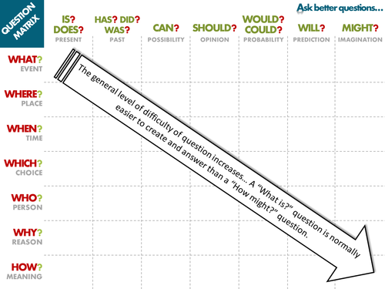

Spelling

Useful websites
https://www.topmarks.co.uk/english-games/7-11-years/spelling-and-grammar
https://www.bbc.co.uk/bitesize/topics/zhrrd2p
Times Tables

Useful websites for games
https://www.topmarks.co.uk/maths-games/7-11-years/times-tables
https://www.timestables.co.uk/2-times-table.html
http://www.primaryhomeworkhelp.co.uk/maths/timestable/interactive.htm
Ideas for activities that don’t need computers or iPads
https://www.theschoolrun.com/top-times-tables-games

